EXPERIMENT – 9
LOGISTIC REGRESSION
Aim:
To perform model classification using Logistic Regression
Procedure:
- Upload the given dataset
- Import all the necessities
- Read and make it as DataFrame
- Through sklearn and train the model
- Test the model

Program:
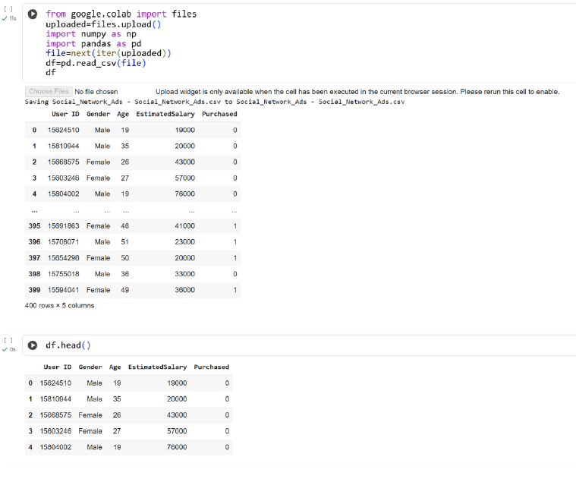

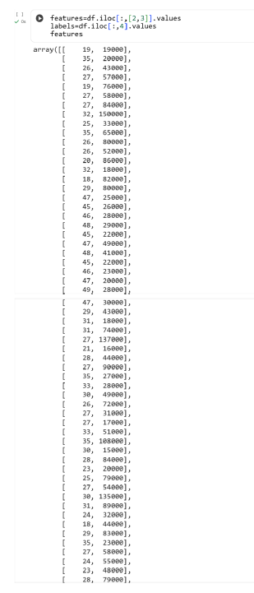

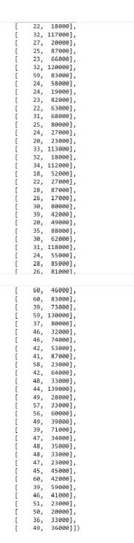

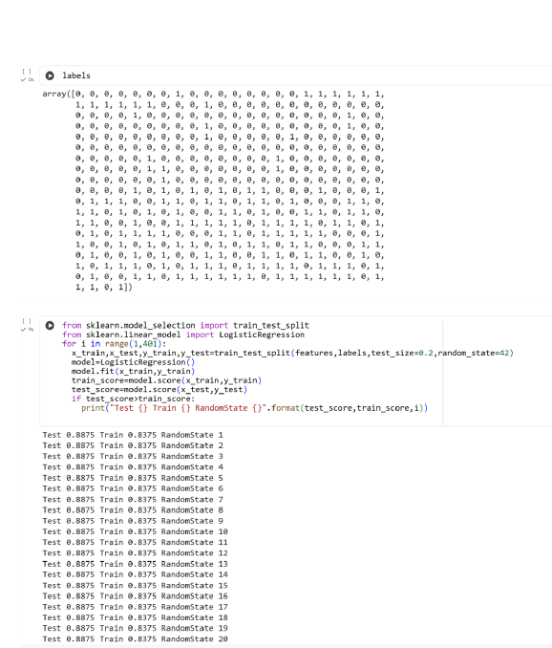

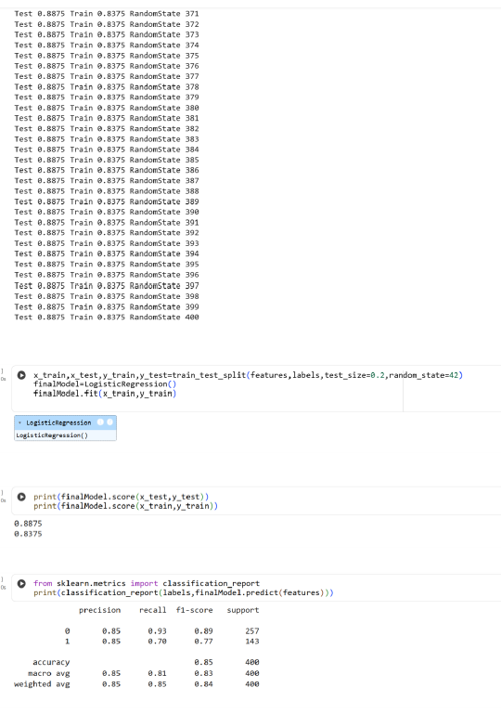
Result:
Thus the python program to perform the model classification using Logistic Regression is executed and verified successfully

